Mathematics — 2006 (Set II — Outside Delhi)
SECFION – A
Q. 1. 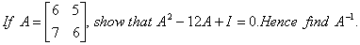
Q. 2. If a, b, c, are in A.P. show the following:
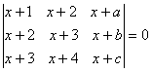
Q. 3. Solve the following differential equation:
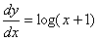
Q. 4. 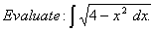
Q. 9. Differentiate from first principle.
Q. 10. 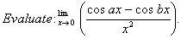
Q. 11. Verify Rolle’s Theorem for the following function:
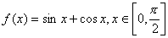
Q. 18. Using matrices, solve the following sys tem of equations:
